Service Lodge Information

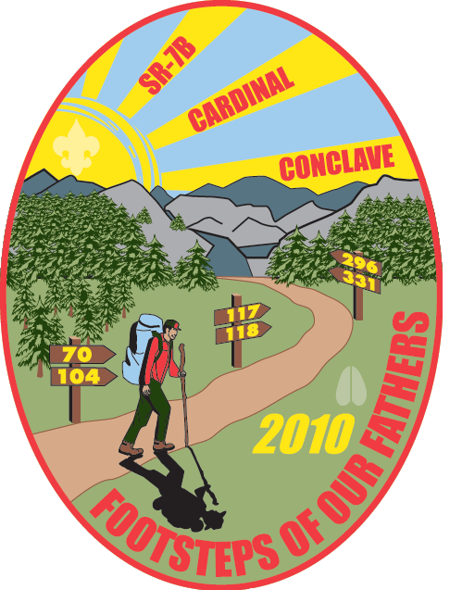

Letter from Conclave Chairman

Brothers of SR-7B,

Croatan Lodge is anxiously awaiting the upcoming SR-7B Conclave in April 2010. With many months of preparation at Camp Boddie, this is set to be a great event which denotes an important milestone in the history of scouting. We hope to make this a memorable Conclave which incorporates the hundredth anniversary of Scouting. In order to accomplish this, the theme for Conclave will be “Footsteps of Our Fathers”, which represents the principles created by Baden Powell during his creation of the Scouting program.

Yours in Brotherhood,

Jordan Byrum
Conclave Chairman

Service Lodge Information

Founder’s Award

Croatan Lodge 117 will present each recipient of the Founder’s Award with a small token at Saturday Evening’s show. Please fill out (Form 8) and return it to us by March 1, 2010.

Special Dietary Needs

Delegates requiring special dietary needs are asked to inform the Service Lodge prior to April 1, 2010 by using (Form 8).

Physical Arrangements

If your lodge has a special request for physical arrangements to accommodate Scouts or Scouters with special needs, please let the Service Lodge know by March 1, 2010 using (Form 7). Lodges needing special arrangements or facilities for their program responsibilities should also submit (Form 16) by
March 1, 2010.

Conclave Planning Committee

Chairman | Adviser
Jordan Byrum  204 Porter St.  Tarboro, NC 27886  252-883-3040  jordan.byrum@gmail.com | Chris Decker  2706 Nash Joyner Rd.  Farmville, NC 27828  252-939-6860  cdecker@croatan.org

- Responsible for working with both the section and the service lodge to ensure a well run event.
- Work with all committees on both their plan of action and budget
- Work with major vendors and committees on what our needs will be for conclave (i.e. memorabilia, food, etc.)
- Prepare preliminary budget and schedule for inclusion in the planbook.
- Prepare close-out budget to Section Key 3 within 90 days post event.

Campsite Host Committee
Chairman | Adviser
Charles Pfeiffer  201 Isabella Avenue  Washington, NC 27889  252-945-9239  rpfeiffer3@suddenlink.net | Hank Dierker  403 Hardy Road  Newport, NC 28570  252-726-5775  hank@starfishnet.com

- Prepare and clean campsites
- Set up 3 wall tents with cots for visiting Key 3 of every lodge and take down after the weekend
- Provide 4 youth and 4 adult arrowmen campsite hosts for each visiting Lodge (5 visiting Lodges)
- Make sure that there is 1 adult and 1 youth in each campsite at all times
- Provide coffee, water and coolers and cups for each campsite and keep them full all weekend
- Have an ample supply of toilet paper, trash bags, etc.
- Respond to all requests of visiting lodges

Communications Committee

Chairman | Advisers
Brad Killebrew  3810 Harts Mill Run Rd.  Tarboro, NC 27886  252-442-7616  bskillebrew91@yahoo.com | Wayne Miller  2174 Quiet Creek Pl.  Rock Hill, SC 29732  803-417-7717  wayne@thrpartners.com | Ken Brown  619 Koonce Fork Rd.  Richlands, NC 28574  910-324-1350  kbrown117@charter.net

- Responsible for daily announcements during meals
- Responsible for intercom announcements
- Provide ample supply of Bonner Maps available
- Setup and man information booths and Internet Kiosk
- Prepare and print Conclave delegate books
- Provide and pass out meal time bulletins
- Obtain copier machines and computers for Conclave
- Determine supply needs and costs for items (paper, etc.)
- Print church service program
- Assist with the production of the Conclave Planbook
- Work with Section Secretary at Conclave to produce publications
- Design and produce Conclave Evaluation Form

Registration & Finance Committee

Chairman | Advisers
Gavin Call  216 Isabella Avenue  Washington, NC 27889  252-414-7032  leandergavincall@hotmail.com | Phil Decker  2499 Irvin Dr.  Kinston, NC 28504  252-522-4258  pdecker@suddenlink.net | Tommy Barus  3404 Hawthorne Rd.  Rocky Mount, NC 27804  252-908-7555  tbarus@suddenlink.net

- Manage Host Lodge Registration Starting May Ordeal 2009
- Manage Lodge Delegate registration process
- Determine registration procedures
- Have name tags printed for Host Lodge
- Provide meal tickets
- Responsible for all money during Conclave
- Prepare Conclave close-out report in consultation with Key 3

Facilities & Grounds Committee
Chairman | Advisers
Sam Tyler  310 Meadows Lane  Maysville, NC 28555  252-743-1877  sjtyler@ncsu.edu | Nelson Medford  419 Boy Scout Road  Blounts Creek, NC 27814  252-946-4085  Nmedford61@gmail.com | Joe Edwards  109 Bobby's Drive  Newport, NC 28570  252-223-5465  CroatanService@hotmail.com

- Assist in setting up and breaking down equipment for events
- Set up OAX area with canopies
- Make sure that all electrical, furniture (tables & chairs), etc. needs are met
- Provide port-a-johns and keep them stocked with toilet paper
- Coordinate cleaning schedule for Headquarters, Health Lodge, and Amphitheater
- Transport items to and from arena as needed
- Deliver ice to concessions as needed
- Appoint a Quartermaster with assistants to serve during Conclave

Food Service Committee

Chairman | Advisers
Chris Fitzgerald  29 Edith Drive  Jacksonville, NC 28540  910-358-9099  chris62789@yahoo.com | Mike Elks  1418 Huckleberry Lane  Winterville, NC 28590  252-756-6766  mlelks@suddenlink.net | Ashley Dail  PO Box 808  Winterville, NC 28590  252-756-6913

- Plan the menus that will be used for the Conclave
- Provide alternate foods for those with special dietary needs
- Secure information for possible tent rental for “Riverside Dining”
- Order the food and all supplies that will be needed
- Provide cracker barrels for the COC meetings
- Prepare Vigil breakfast on Saturday morning
- Assemble a cook crew staff
- Develop a serving rotation for all meals
- Responsible for dining hall cooking, cleaning, and preparation

Hospitality & VIP Committee

Chairman | Advisers
Ben Averitt  104 Bryan Boulevard  Havelock, NC 28532  252-229-8388  coreesunderated@hotmail.com | Wayne Boyette  204 West Park Avenue  Tarboro, NC 27886  252-641-1433  unctarheel1984@yahoo.com | Carol Cantu  302 Darden Dr.  Kinston, NC 28504  252-522-2327  cicantu@yahoo.com

- Responsible for daily flag raising
- Responsible for obtaining minister for Sunday service
- Provide transportation, housing, and guides for all VIP guests
- Secure supplies for the VIA luncheon (table cloths, plates, silverware, etc.)
- Help serve the VIA meal
- Responsible for patch trading facilities
- Collect “stuff” and prepare delegate packs

Trading Post Committee
Chairman | Advisers
Matt Williamitis  612 East Main Street  Washington, NC 27889  252-944-1992  mattwilliamitis@aol.com | Roland Lanouette  4617 Honeysuckle Lane  Rocky Mount, NC 27804  252-451-9385  ramd@cox.net | Tom Hendricks  103 Corolla Ct.  Jacksonville, NC 28546  910-346-3068  thendricks1@ec.rr.com

- Oversee all functions of the Trading Post
- Plan and order all food items to be sold in the Trading Post
- Provide schedules of operation for main TP and satellite TPs.
- Work with the Section to ensure all Conclave memorabilia is ordered and delivered
- Order all Trading Post items (concessions, supplies, etc.)
- Take pre- and post-Conclave inventories
- Responsible for delivering Conclave pre-orders to campsites
- Help prepare close-out report

Indian Affairs Committee
Chairman | Adviser
Jessie Hathaway  320 Hubnell Road  Ernul, NC 28527  252-474-9015  jah0627@ecu.edu | Eddie Cahoon  419 Boy Scout Road  Blounts Creek, NC 27814  252-917-7592  eccahoon@aol.com

- Work with Section IA Committee to plan and execute all IA activities during Conclave
- Set up the Dance Arbor, Indian Village and Ceremonies Ring
- Provide lunch for the dancers and judges
- Provide water for dancers and judges
- Assist in recruit M.C. for competitions
- Obtain PA system
- Assist in recruiting judges from outside the Section if possible

Security & Logistics Committee
Chairman | Advisers
Dalton Barrett  509 N Walnut St.  Spring Hope, NC 27882  252-478-7018  barrettdalton31@yahoo.com | David Harper  1546 Green Road  Spring Hope, NC 27882  252-478-4423  scout85@embarqmail.com | James Smith  208 King Richard Court  Jacksonville, NC 28546  910-938-8899  tanks1@earthlink.net

- Design the check-in procedures for Friday
- Develop a parking plan for visiting lodges, Saturday visitors, host lodge vehicles
- Supervise all parking
- Man front gate with informed people
- Get parking passes printed for visiting lodges and host lodge vehicles
- Secure radios and coordinate their use for the weekend
- Supervise traffic flow
- Design the check-out procedures for Sunday

Shows Committee
Chairman | Advisers
Robert Dail  315 North Charlotte Street  Washington, NC 27889  252-946-5665  robert.dail@gmail.com | Dal Newbold  612 East Main Street  Washington, NC 27889  252-946-0406  daln@embarqmail.com | Ronnie Spence  621 Park Avenue  Roanoke Rapids, NC 27870  252-537-1683  ronspence@earthlink.net

- Obtain sound and lighting system
- Provide Friday and Saturday night shows (Using Footsteps of Our Fathers Theme)
- Arrange for entertainment for 30-45 minutes prior to show
- Man the arena at all times
- Obtain small candles for Saturday night’s show
- Conduct a meaningful presentation for Founder’s Award Recipients
- Conduct a meaningful Vigil Rededication Ceremony

Health & Safety Committee
Chairman | Advisers
Randall Spence  621 Park Avenue  Roanoke Rapids, NC 27870  252-537-1683  startrek1@embarqmail.com | David Smith  1716 Deep River Road High Point, NC 27265  336-886-7998  dsmith1117@yahoo.com | Norm Belmore  318 Country Club Drive Jacksonville, NC 28546  910-346-4395  nabjr104@earthlink.net

- Obtain a medic (EMT) for the weekend
- Responsible for checking medical forms of all Conclave participants
- Store medical records properly during the Conclave and return to each Lodge upon departure
- Provide first aid teams equipped with radios at Conclave activities (Dance Arbor, Quest, Ceremony Competition, OAX, etc.)
- Develop, test, and implement a plan for transportation to the local hospital with backup transportation available
- Maintain Health Lodge as First Aid HQ with personnel available around the clock
- Keep Health Lodge building grounds clean before, during, and after the Conclave
- Provide a plan for Medivac and secure a landing zone site
- Assist with Blood Mobile operations

OAX Committee
Chairman | Adviser
Seiler Hagan  1404 Clifton Rd  Jacksonville, NC 28540  910-346-303  sy@ec.rr.com | Brian Snow  103 Sand Run Rd.  Havelock, NC 28532  252-447-2362  acts2@ec.rr.com

- Work with Section to facilitate OAX
- Obtain vendors to exhibit their services and products
- Provide resources for vendors
- Organize exhibit site for good flow of traffic
- Work with the Section Promotions team to promote the event on Conclave website and throughout the Conclave
- Solicit door prizes from the vendors

Garbage & Recycling Committee
Chairman | Advisers
TBA | TBA | TBA

- Put out garbage cans and recycling containers in campsites, at trading post, arena, OAX, and in all event and program areas
- Empty trash cans and recycling containers as needed
- Obtain containers to utilize as recycling bins for the weekend
- Secure extra dumpsters for use during the event
- Arrange for transportation of recycled materials to appropriate county disposal site post-Conclave
- Setup site as storage for recycled materials near camp exit
- Promote recycling throughout the weekend with appropriate signage and in the mealtime bulletins.
- Calculate and publicize amount of recycled materials collected

Preliminary Conclave Schedule

Friday - April 16, 2010
12:00pm Check-in begins Campsites
6:00-8:00pm Floating Supper Dining Hall
8:15pm Pep Rally Arena
8:30pm Opening Show Arena
9:45pm New Member Reception Arena
10:00pm Council of Chiefs Kennedy Center, Sea Base
Cracker-barrel Campsites
11:00pm Taps

Saturday - April 17, 2010
6:15am Vigil Breakfast Dining Hall
7:00am Vigil Rededication Arena
7:00am 1st Breakfast Dining Hall
7:45am 2nd Breakfast Dining Hall
8:30am Flag Raising Sea Base
8:30am Ceremonies Judges Training Indian Village
9:00am OAX Opens Sea Base
Team Dance Competition Dance Arbor
9:30am Pre-Ordeal Ceremony Competition Indian Village
9:30am Brotherhood Ceremony Competition Nature Trail
Indian Cultural/Village Exhibit Indian Village
10:00am Individual Dance Registration Dance Arbor
11:00am Team Dance & Singing Dance Arbor
11:30am-1:30pm Floating Lunch Main Trading Post & TP Satellites
12:00pm VIA Luncheon Kennedy Center, Sea Base
12:30pm Regalia Judging Dance Arbor
1:00pm Individual Dance Competition Dance Arbor
2:00pm OAX Closes
2:30pm Quest Events Activity Field
4:30pm Candidates Forum & Election Arena
Section Elections Arena
5:30pm Council of Chiefs Kennedy Center, Sea Base
5:45pm 1st Supper Dining Hall
6:30pm 2nd Supper Dining Hall
7:15pm Patch Auction Teepees
8:00pm Pep Rally Arena
8:15pm Show Arena
9:45pm Saturday Night Sundaes Dining Hall Lawn
10:00pm Powwow Dance Arbor
11:00pm Taps

Sunday – April 18, 2010
7:00am Lodge Advisers Breakfast Dining Hall
7:30am 1st Breakfast Dining Hall
8:15am 2nd Breakfast Dining Hall
9:00am Inter-Faith Worship Service Arena
9:15am Closing Ceremony & Awards Arena

Directions to Camp Boddie
(formerly known as Camp Bonner)

Camp Boddie is located at:
419 Camp Bonner Boy Scout Road
Blounts Creek, NC 27814

Map it at Google Maps!

From Greenville: Take NC 33 into Chocowinity. Cross the US 17 - NC 33 intersection and travel 1.5 miles to Old Blount's Creek Road. Turn left and go approximately 6 miles and turn left on to Mouth of the Creek Road. Camp Boddie will be 4 miles on your left.
From Raleigh/Wilson: Take US 264 east into Washington. Turn right at the intersection of US 264
and US 17. Continue on 17 into the town of Chocowinity. Turn left at the intersection of US 17 and NC 33. Go 1.5 miles and turn left on to Old Blounts Creek Road. Go approximately 6 miles and turn left on to Mouth of the Creek Road. Camp Boddie will be 4 miles on your left.
From Williamston: Take US 17 south to Chocowinity. At the intersection of 17 and NC 33 make a left and go 1.5 miles to Old Blount's Creek Road and turn left. Go approximately 6 miles and turn left on to Mouth of the Creek Road. Camp Boddie will be 4 miles on your left.
From New Bern: Take US 17 north to the intersection of NC 33 in Chocowinity and
turn right. Go 1.5 miles to Old Blount's Creek Road and turn left. Go approximately 6 miles and turn left on to Mouth of the Creek Road. Camp Boddie will be 4 miles on your left.
By Boat: Refer to the most current NOAA Chart #11554. The East Carolina Scout Reservation waterfront is located at approximately 76* 57' N by 35* 26' 25" W.
NOTE: Persons planning an arriving by boat MUST contact the Sea Base Director at least two weeks in advance of their arrival.

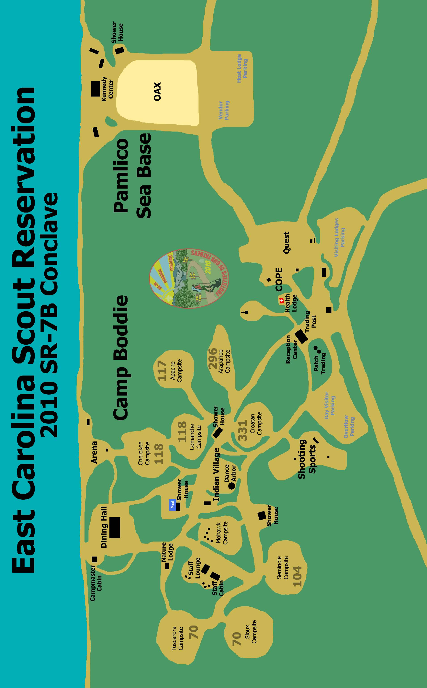
SR-7B Conclave 2010 Proposed Budget

